Create a new React Application with the name “myfirstreact”, Run the application to print “welcome to the first session of React” as heading of that page.
- To create a new React app, Install Nodejs and Npm from the following link:
https://nodejs.org/en/download/
- Install Create-react-app by running the following command in the command prompt:

- To create a React Application with the name of “myfirstreact”, type the following command:

- Once the App is created, navigate into the folder of myfirstreact by typing the following command:
- Open the folder of myfirstreact in Visual Studio Code
- Open the App.js file in Src Folder of myfirstreact
- Remove the current content of “App.js”
- Replace it with the following:

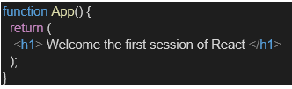

- Run the following command to execute the React application:

- Open a new browser window and type “localhost:3000” in the address bar
SOLUTION:
App.js:
import React from 'react';
import './App.css';

function App() {
return (
<div className="App">
<h1>welcome to the first session of React</h1>
</div>
);
}

export default App;
SOLUTION:
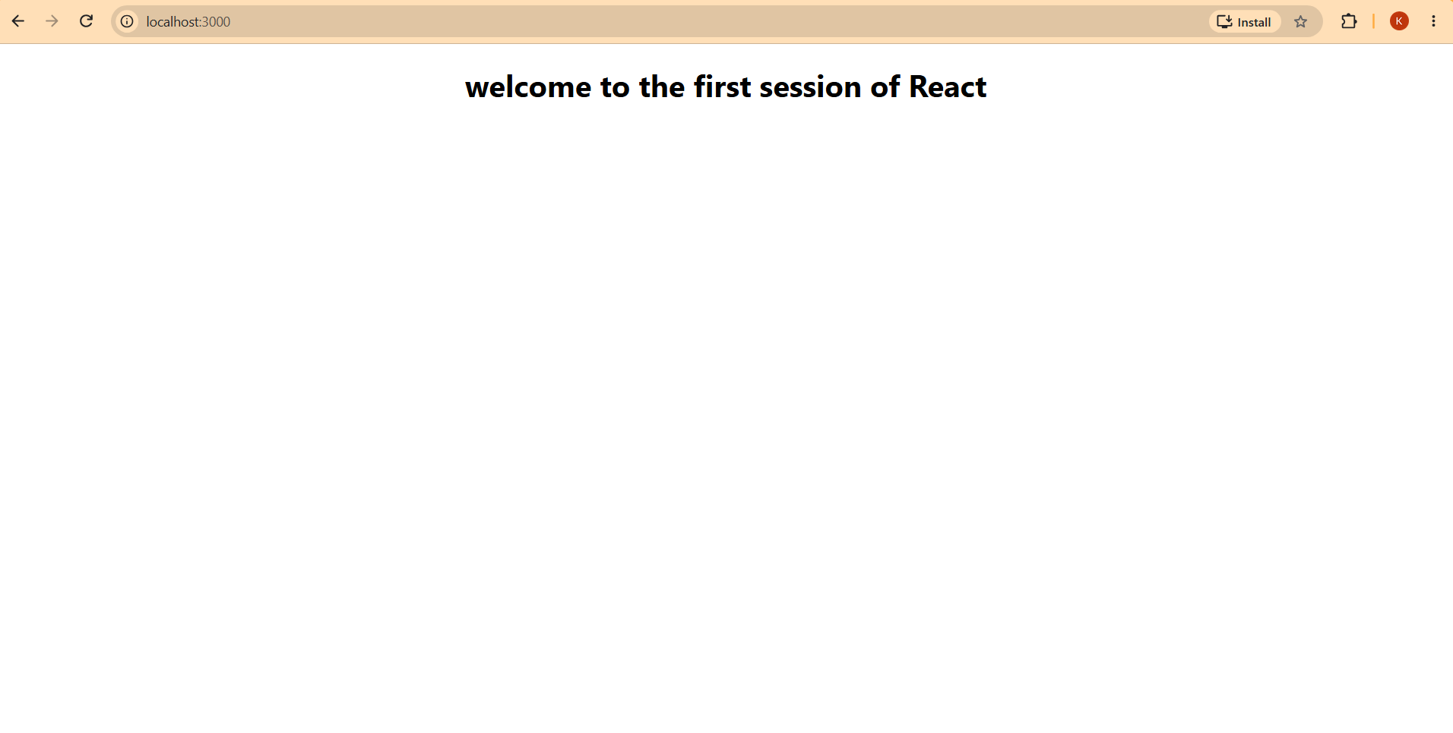
Create a react app for Student Management Portal named StudentApp and create a component named Home which will display the Message “Welcome to the Home page of Student Management Portal”. Create another component named About and display the Message “Welcome to the About page of the Student Management Portal”. Create a third component named Contact and display the Message “Welcome to the Contact page of the Student Management Portal”. Call all the three components.

- Create a React project named “StudentApp” type the following command in terminal of Visual studio:

- Create a new folder under Src folder with the name “Components”. Add a new file named “Home.js”

- Type the following code in Home.js

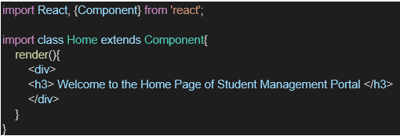

- Under Src folder add another file named “About.js”

- Repeat the same steps for Creating “About” and “Contact” component by adding a new file as ”About.js”, “Contact.js” under “Src” folder and edit the code as mentioned for “Home” Component.

- Edit the App.js to invoke the Home, About and Contact component as follows:

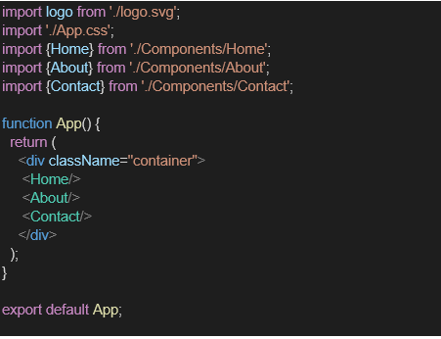

- In command Prompt, navigate into StudentApp and execute the code by typing the following command:

- Open browser and type “localhost:3000” in the address bar:
SOLUTION:
Home.js
import React from 'react';

function Home() {
return (
<div>
<h2>Welcome to the Home page of Student Management Portal</h2>
</div>
);
}

export default Home;
About.js
import React from 'react';

function About() {
return (
<div>
<h2>Welcome to the About page of the Student Management Portal</h2>
</div>
);
}

export default About;
Contact.js
import React from 'react';

function Contact() {
return (
<div>
<h2>Welcome to the Contact page of the Student Management Portal</h2>
</div>
);
}

export default Contact;
App.js
import React from 'react';
import './App.css';
import Home from './Components/Home';
import About from './Components/About';
import Contact from './Components/Contact';

function App() {
return (
<div className="App">
<h1>Student Management Portal</h1>
<hr />
<Home />
<About />
<Contact />
</div>
);
}

export default App;
RESULT:
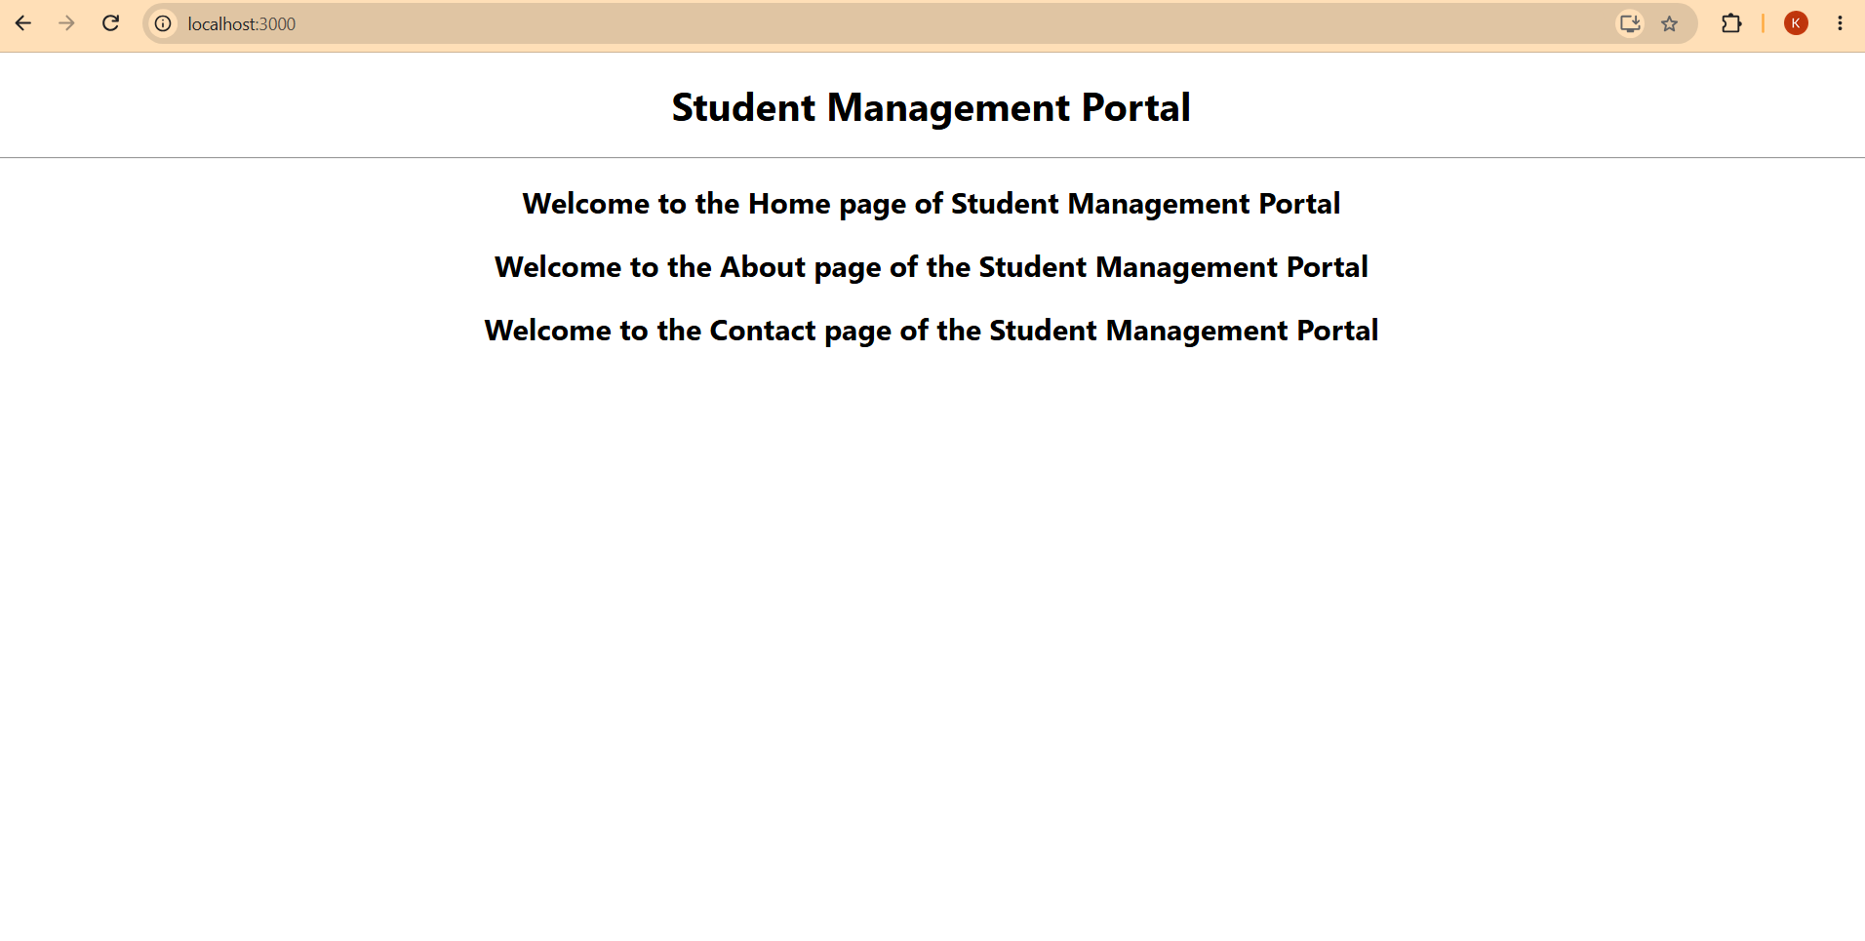
Create a react app for Student Management Portal named scorecalculatorapp and create a function component named “CalculateScore” which will accept Name, School, Total and goal in order to calculate the average score of a student and display the same.

- Create a React project named “scorecalculatorapp” type the following command in terminal of Visual studio:

- Create a new folder under Src folder with the name “Components”. Add a new file named “CalculateScore.js”

- Type the following code in CalculateScore.js

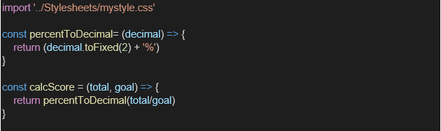
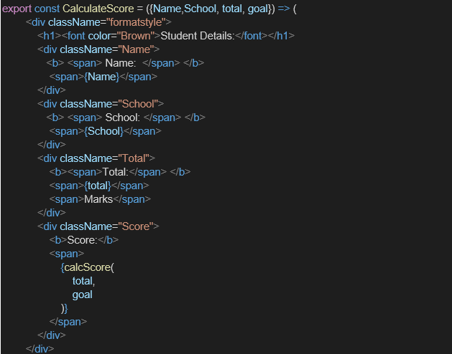

- Create a Folder named Stylesheets and add a file named “mystyle.css” in order to add some styles to the components:

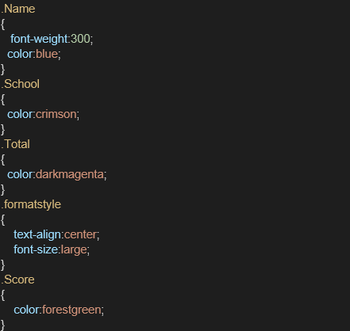

- Edit the App.js to invoke the CalculateScore functional component as follows:

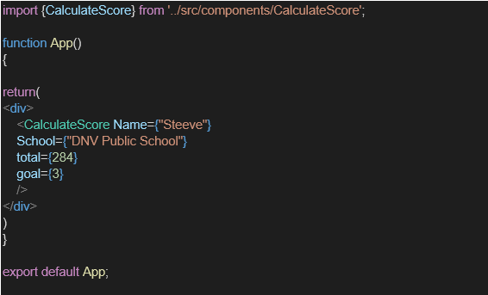

- In command Prompt, navigate into scorecalculatorapp and execute the code by typing the following command:

- Open browser and type “localhost:3000” in the address bar:
SOLUTION:
CalculateScore.js
import React from 'react';
import '../Stylesheets/mystyle.css'; // This links our component to the styling we will make next

function CalculateScore(props) {
// Calculate the percentage score based on Total out of Goal
const averageScore = ((props.Total / props.Goal) * 100).toFixed(2);

return (
<div className="score-card">
<h2>Student Score Details</h2>
<p><strong>Name:</strong> {props.Name}</p>
<p><strong>School:</strong> {props.School}</p>
<p><strong>Total Marks Secured:</strong> {props.Total}</p>
<p><strong>Out Of (Goal):</strong> {props.Goal}</p>
<div className="result-badge">
<h3>Average Score: {averageScore}%</h3>
</div>
</div>
);
}

export default CalculateScore;
App.js:
import React from 'react';
import './App.css';
import CalculateScore from './Components/CalculateScore';

function App() {
return (
<div className="App">
<h1 style={{ textAlign: 'center', marginTop: '20px' }}>Student Management Portal</h1>
{/* We are passing custom values into our component using props right here! */}
<CalculateScore
Name="John Doe"
School="Greenwood High School"
Total={425}
Goal={500}
/>
</div>
);
}

export default App;
RESULT:
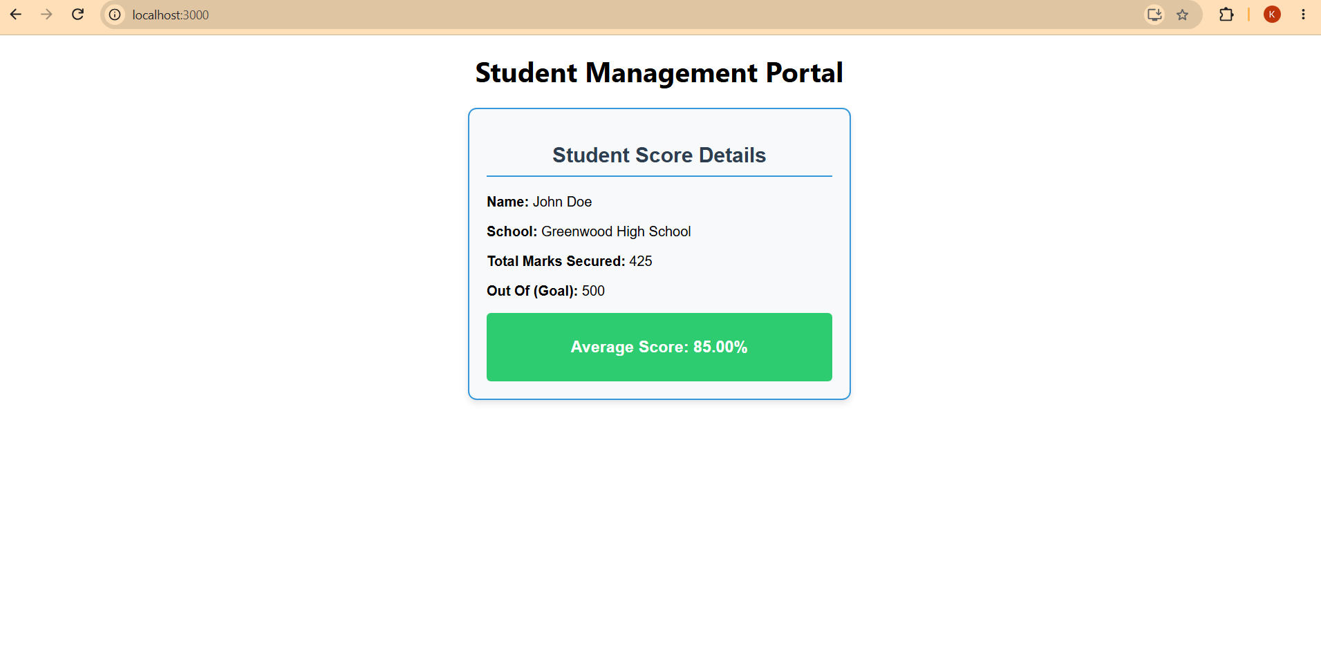
- Create a new react application using create-react-app tool with the name as “blogapp”
- Open the application using VS Code
- Create a new file named as Post.js in src folder with following properties

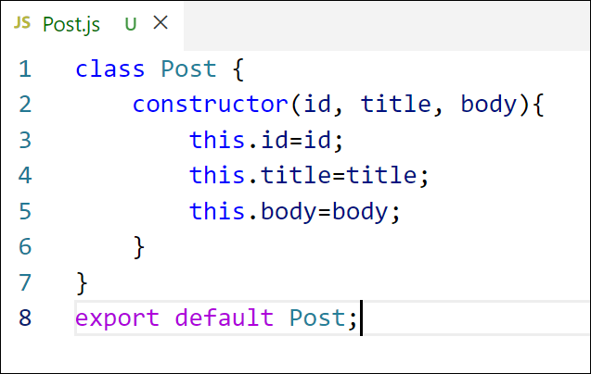
Figure 2: Post class
- Create a new class based component named as Posts inside Posts.js file
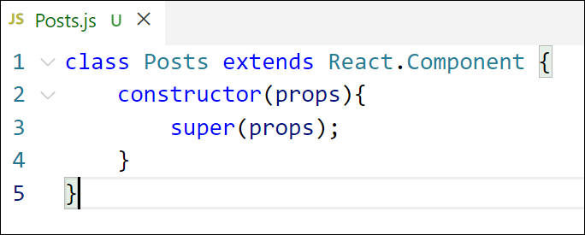
Figure 3: Posts Component
- Initialize the component with a list of Post in state of the component using the constructor
- Create a new method in component with the name as loadPosts() which will be responsible for using Fetch API and assign it to the component state created earlier. To get the posts use the url (https://jsonplaceholder.typicode.com/posts)

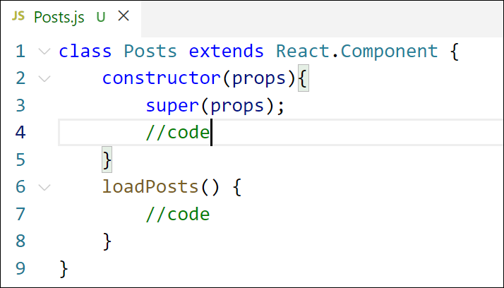
Figure 4: loadPosts() method
- Implement the componentDidMount() hook to make calls to loadPosts() which will fetch the posts

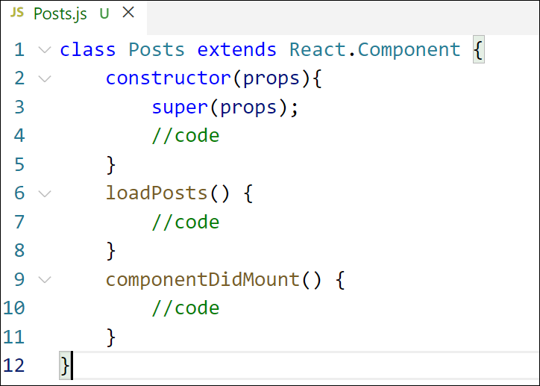
Figure 5: componentDidMount() hook
- Implement the render() which will display the title and post of posts in html page using heading and paragraphs respectively.

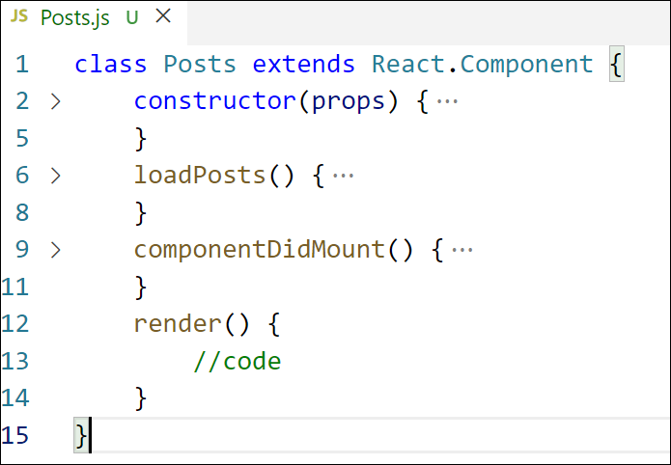
Figure 6: render() method
- Define a componentDidCatch() method which will be responsible for displaying any error happing in the component as alert messages.

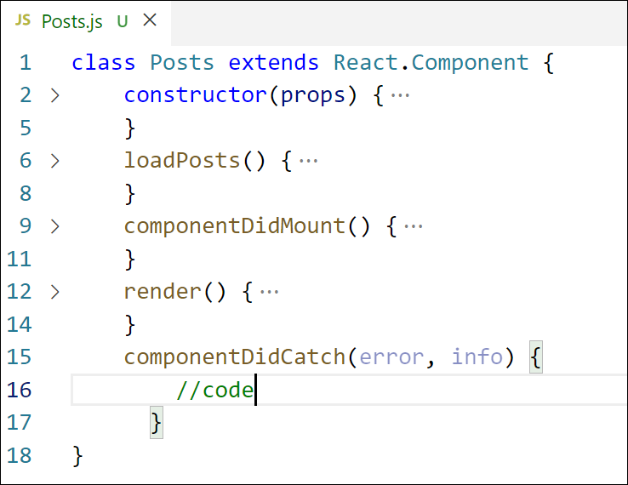
Figure 7: componentDidCatch() hook
- Add the Posts component to App component.
- Build and Run the application using npm start command.
SOLUTION:
Post.js
class Post {
constructor(id, title, body) {
this.id = id;
this.title = title;
this.body = body;
}
}

export default Post;
Posts.js
import React, { Component } from 'react';
import Post from './Post';

class Posts extends Component {
// Step 5: Initialize state inside the constructor
constructor(props) {
super(props);
this.state = {
blogPosts: [], // Will hold our list of posts
hasError: false
};
}

// Step 6: Fetch data using the Fetch API
loadPosts() {
fetch('https://jsonplaceholder.typicode.com/posts')
.then(response => {
if (!response.ok) {
throw new Error('Network response was not ok');
}
return response.json();
})
.then(data => {
// Map the incoming JSON arrays into our Post class structures
const formattedPosts = data.slice(0, 10).map(item => new Post(item.id, item.title, item.body));
// We sliced it to 10 items just so your screen isn't overwhelmed!

this.setState({ blogPosts: formattedPosts });
})
.catch(error => {
// Trigger local error state
this.setState({ hasError: true });
this.componentDidCatch(error, "Error loading posts");
});
}
componentDidMount() {
this.loadPosts(); // Automatically runs as soon as the component loads on screen
}
componentDidCatch(error, info) {
alert(`An error occurred: ${error.message}`);
}
render() {
if (this.state.hasError) {
return <h3 style={{color: 'red'}}>Failed to load blog posts. Check your connection.</h3>;
}

return (
<div style={{ maxWidth: '600px', margin: '0 auto', textAlign: 'left', padding: '20px' }}>
<h2>Latest Blog Posts</h2>
<hr />
{this.state.blogPosts.map(post => (
<div key={post.id} style={{ marginBottom: '25px', paddingBottom: '15px', borderBottom: '1px solid #ddd' }}>
<h3 style={{ textTransform: 'capitalize', color: '#2c3e50' }}>{post.title}</h3>
<p style={{ color: '#555', lineHeight: '1.6' }}>{post.body}</p>
</div>
))}
</div>
);
}
}

export default Posts;
App.js
import React from 'react';
import './App.css';
import Posts from './Posts';

function App() {
return (
<div className="App">
<header style={{ backgroundColor: '#2c3e50', padding: '20px', color: 'white', marginBottom: '20px' }}>
<h1>My Personal Blog Application</h1>
</header>
<Posts />
</div>
);
}

export default App;
RESULT:
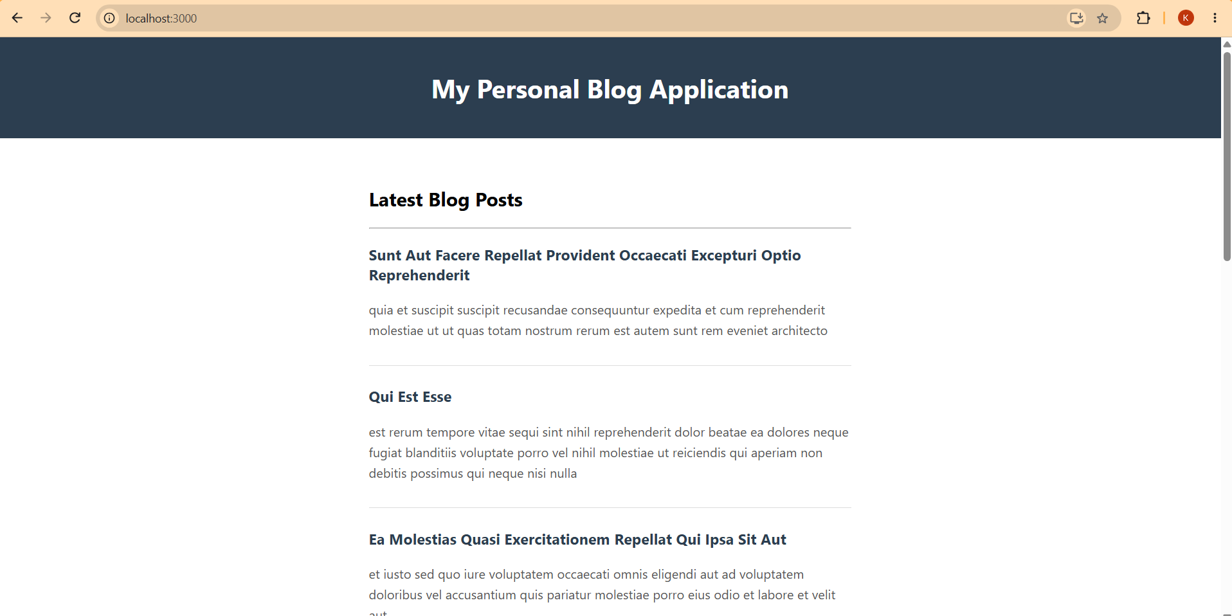
Estimated time to complete this lab: 30 minutes.

My Academy team at Cognizant want to create a dashboard containing the details of ongoing and completed cohorts. A react application is created which displays the detail of the cohorts using react component. You are assigned the task of styling these react components.
Download and build the attached react application.
- Unzip the react application in a folder
- Open command prompt and switch to the react application folder
- Restore the node packages using the following commands
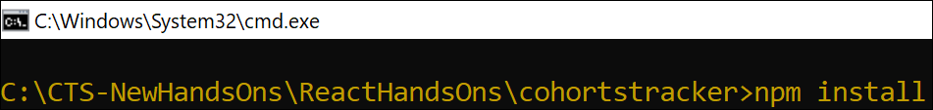
Figure 1: Restore packages
- Open the application using VS Code
- Create a new CSS Module in a file called “CohortDetails.module.css”
- Define a css class with the name as “box” with following properties
Width = 300px;
Display = inline block;
Overall 10px margin
Top and bottom padding as 10px
Left and right padding as 20px
1 px border in black color
A border radius of 10px
- Define a css style for html <dt> element using tag selector. Set the font weight to 500.
- Open the cohort details component and import the CSS Module
- Apply the box class to the container div
- Define the style for <h3> element to use “green” color font when cohort status is “ongoing” and “blue” color in all other scenarios.
- Final result should look similar to the below image
SOLUTION:
CohortDetails.module.css
/* Outer container to arrange cards side-by-side */
.container {
display: flex;
flex-wrap: wrap;
gap: 20px;
padding: 20px;
justify-content: center;
}

/* Base card styling */
.card {
border: 1px solid #e2e8f0;
border-radius: 8px;
padding: 20px;
width: 280px;
box-shadow: 0 4px 6px -1px rgba(0, 0, 0, 0.1);
background-color: #ffffff;
font-family: Arial, sans-serif;
text-align: left;
}

/* Cohort title/code header */
.title {
font-size: 1.1rem;
font-weight: bold;
color: #000066;
margin-bottom: 12px;
border-bottom: 2px solid #000066;
padding-bottom: 6px;
}

/* Field labels */
.label {
font-weight: bold;
color: #4b5563;
margin-top: 10px;
font-size: 0.9rem;
}

/* Field values */
.value {
margin-bottom: 8px;
color: #1f2937;
font-size: 0.95rem;
}

/* Conditional Status Styles */
.statusScheduled {
font-weight: bold;
color: #1d4ed8;
background-color: #dbeafe;
padding: 4px 10px;
border-radius: 4px;
display: inline-block;
margin-top: 4px;
margin-bottom: 8px;
font-size: 0.85rem;
}

.statusOngoing {
font-weight: bold;
color: #15803d;
background-color: #dcfce7;
padding: 4px 10px;
border-radius: 4px;
display: inline-block;
margin-top: 4px;
margin-bottom: 8px;
font-size: 0.85rem;
}
CohortDetails.js
import React from 'react';
import styles from './CohortDetails.module.css';

const CohortDetails = () => {
const cohorts = [
{
code: "INTADMDF10 -.NET FSD",
startDate: "22-Feb-2022",
status: "Scheduled",
coach: "Aathma",
trainer: "Jojo Jose"
},
{
code: "ADM21JF014 -Java FSD",
startDate: "10-Sep-2021",
status: "Ongoing",
coach: "Apoorv",
trainer: "Elisa Smith"
},
{
code: "CDBJF21025 -Java FSD",
startDate: "24-Dec-2021",
status: "Ongoing",
coach: "Aathma",
trainer: "John Doe"
},
{
code: "INTADMJF12 -Java FSD",
startDate: "22-Feb-2022",
status: "Scheduled",
coach: "Ibrahim",
trainer: "To Be Assigned"
},
{
code: "CDE22JF011 -Java FSD",
startDate: "24-Dec-2021",
status: "Ongoing",
coach: "Apoorv",
trainer: "Emma Swan"
},
{
code: "INTADMDF09 -Dataware Housing",
startDate: "22-Feb-2022",
status: "Scheduled",
coach: "Aathma",
trainer: "Babjee Rao"
},
{
code: "ADM22DF001 -.NET FSD",
startDate: "10-Sep-2021",
status: "Ongoing",
coach: "Ibrahim",
trainer: "Marie Curie"
}
];

return (
<div>
<h2 style={{ textAlign: 'center', margin: '20px 0', color: '#000066' }}>
Cohorts Details
</h2>
<div className={styles.container}>
{cohorts.map((cohort, index) => (
<div key={index} className={styles.card}>
<div className={styles.title}>{cohort.code}</div>

<div className={styles.label}>Started On</div>
<div className={styles.value}>{cohort.startDate}</div>

<div className={styles.label}>Current Status</div>
<div
className={
cohort.status === 'Scheduled'
? styles.statusScheduled
: styles.statusOngoing
}
>
{cohort.status}
</div>

<div className={styles.label}>Coach</div>
<div className={styles.value}>{cohort.coach}</div>

<div className={styles.label}>Trainer</div>
<div className={styles.value}>{cohort.trainer}</div>
</div>
))}
</div>
</div>
);
};

export default CohortDetails;
RESULT:
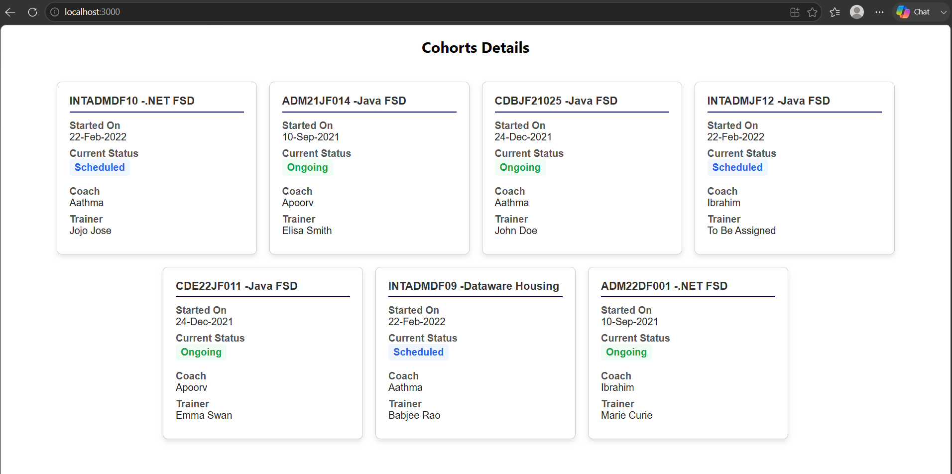
Cognizant Academy teams want to maintain a list of trainers along with their expertise in a SPA using React as the technology. You are assigned the task of creating this React app.
The following trainers’ data application will deal.
- T-ID
- Name
- Phone
- Email
- Stream
- Skills

- Create a new React app using create-react-app tool with the as “TrainersApp”
- Open the application using the VS Code
- Add a new file called trainer.js inside the src folder and define a class named as “Trainer” with the following properties
  - TrainerId
  - Name
  - Email
  - Phone
  - Technology
  - Skills
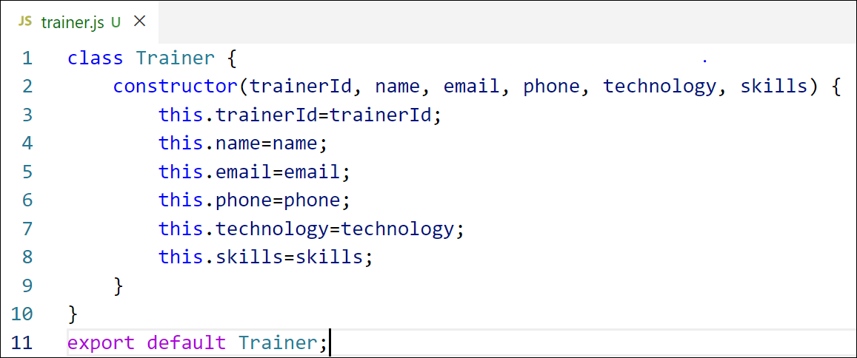
Figure 2: Trainer.js
- Create a new TrainersMock.js file which will contain the mock trainer data. Refer the following screenshot for mock data
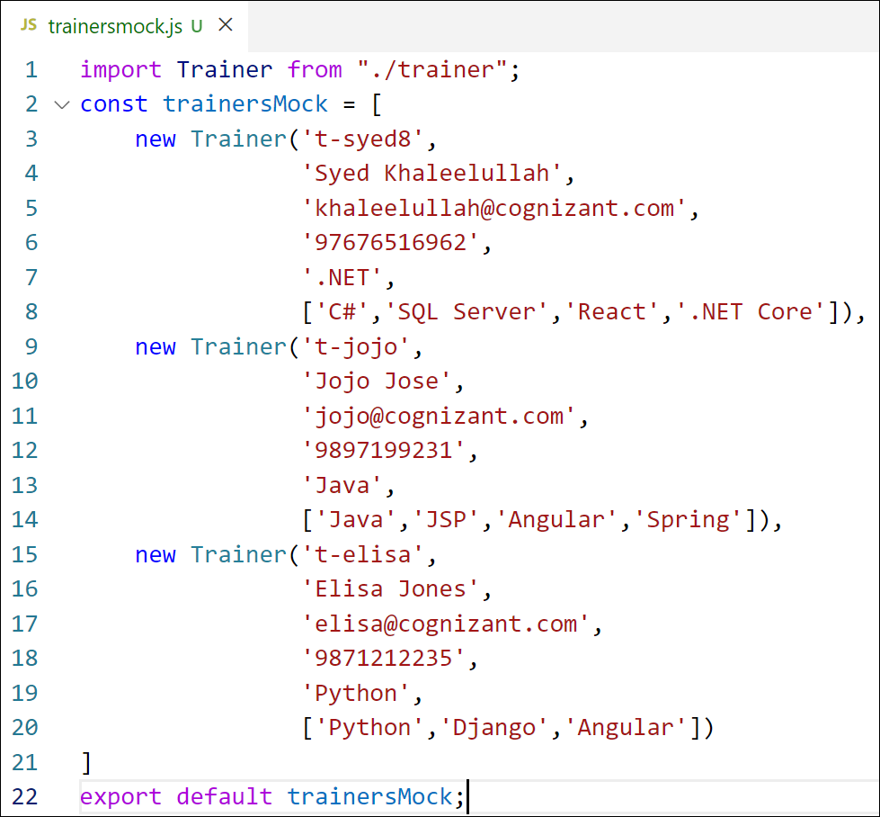
Figure 3: TrainersMock.js

- Install the support for React router for the dom. Execute the following command.
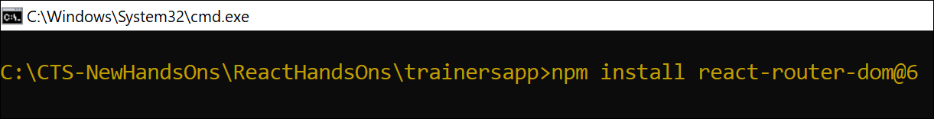
Figure 4: Install React Router
- Create new component named as TrainersList inside Trainerlist.js file. The component should accept the trainer’s data as parameter and render it as a list. The list should display names of each trainers which must be clickable like a hyper link. Refer the following screenshot for the component layout.

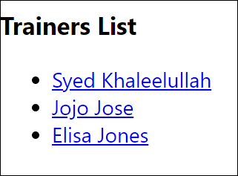
Figure 5: TrainersList Component
- Create a new component named as Home inside Home.js which will be responsible for displaying the following

Figure 6: Home Component
- Modify the App component to add support for routing and defining the navigation links to Home component and TrainersList component. Use BrowserRouter, Routes, Route and Link components from the react-router-dom library.
Define the following URL
- / - must redirect to home component
- /trainers – must redirect to trainers list component.
The layout of the page must be similar to the following

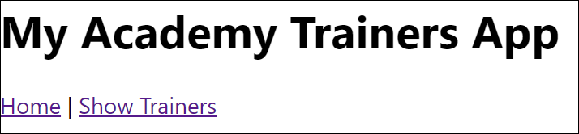
Figure 7: App Component
- Create a new component named TrainerDetail in TrainerDetails.js file.
The component should retrieve a parameter named id from the URL with the help of “useParams” hook from the React router DOM library.
It should query the mock trainer data using the id and display the trainer details as show in screenshot.
Modify the TrainersList component to add Links to TrainerDetail component while passing the ID. Define a route in App component for the same.

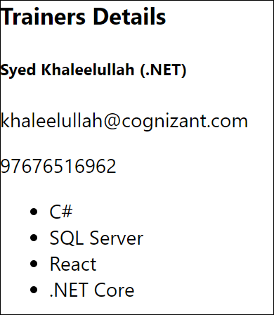
Figure 8: Trainers Detail Component
- Build and run the application. The complete layout of the application will look as follows.
SOLUTION:
trainer.js
class Trainer {
constructor(trainerId, name, email, phone, technology, skills) {
this.trainerId = trainerId;
this.name = name;
this.email = email;
this.phone = phone;
this.technology = technology;
this.skills = skills;
}
}

export default Trainer;
TrainersMock.js:
import Trainer from "./trainer";

const trainersMock = [
new Trainer(
't-syed8',
'Syed Khaleelullah',
'khaleelullah@cognizant.com',
'97676516962',
'.NET',
['C#', 'SQL Server', 'React', '.NET Core']
),
new Trainer(
't-jojo',
'Jojo Jose',
'jojo@cognizant.com',
'9897199231',
'Java',
['Java', 'JSP', 'Angular', 'Spring']
),
new Trainer(
't-elisa',
'Elisa Jones',
'elisa@cognizant.com',
'9871212235',
'Python',
['Python', 'Django', 'Angular']
)
];

export default trainersMock;
Home.js
import React from 'react';

function Home() {
return (
<div>
<h2>Welcome to My Academy trainers page</h2>
</div>
);
}

export default Home;
Trainerlist.js
import React from 'react';
import { Link } from 'react-router-dom';

function TrainersList({ trainers }) {
return (
<div>
<h2>Trainers List</h2>
<ul>
{trainers.map((trainer) => (
<li key={trainer.trainerId}>
<Link to={`/trainers/${trainer.trainerId}`}>
{trainer.name}
</Link>
</li>
))}
</ul>
</div>
);
}

export default TrainersList;
TrainerDetails.js
import React from 'react';
import { useParams } from 'react-router-dom';
import trainersMock from './TrainersMock';

function TrainerDetail() {
const { id } = useParams();
const trainer = trainersMock.find((t) => t.trainerId === id);

if (!trainer) {
return <h2>Trainer Not Found</h2>;
}

return (
<div>
<h2>Trainers Details</h2>
<h3>
{trainer.name} ({trainer.technology})
</h3>
<p>{trainer.email}</p>
<p>{trainer.phone}</p>
<ul>
{trainer.skills.map((skill, index) => (
<li key={index}>{skill}</li>
))}
</ul>
</div>
);
}

export default TrainerDetail;
RESULT:
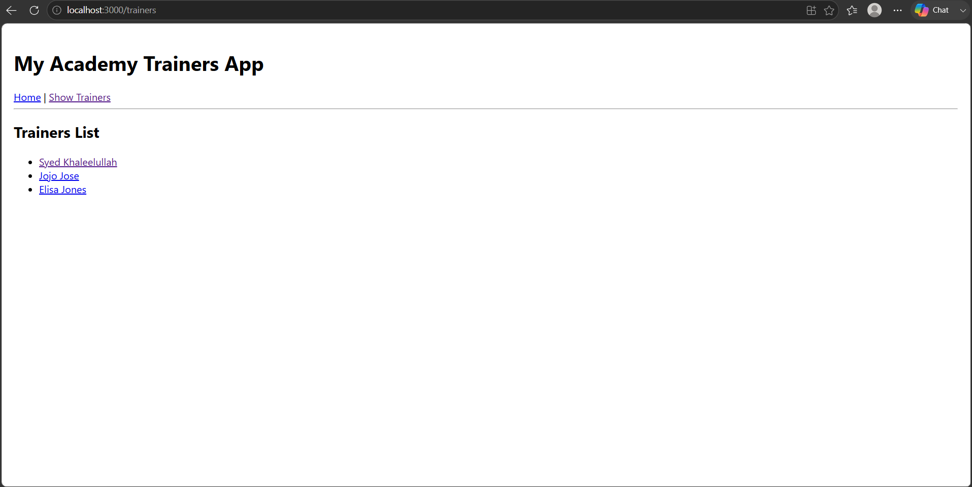
Create a React Application named “shoppingapp” with a class component named “OnlineShopping” and “Cart”.
- In Cart class, create 2 properties as mentioned below:
- Itemname
- Price
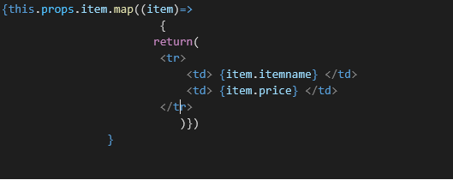
- In OnlineShopping class, create an array of Cart and initialize 5 items.

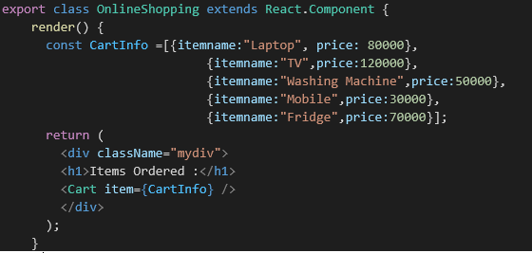

- Loop through these items and display the data as shown below:
SOLUTION:
Cart.js:
import React, { Component } from 'react';

export class Cart extends Component {
render() {
return (
<table border="1" style={{ margin: '0 auto', borderCollapse: 'collapse', borderColor: '#2e7d32' }}>
<thead>
<tr>
<th style={{ color: '#2e7d32', padding: '8px 20px' }}>Name</th>
<th style={{ color: '#2e7d32', padding: '8px 20px' }}>Price</th>
</tr>
</thead>
<tbody>
{this.props.item.map((item, index) => {
return (
<tr key={index}>
<td style={{ color: '#2e7d32', padding: '8px 20px' }}>{item.itemname}</td>
<td style={{ color: '#2e7d32', padding: '8px 20px' }}>{item.price}</td>
</tr>
);
})}
</tbody>
</table>
);
}
}

export default Cart;
OnlineShopping.js:
import React from 'react';
import Cart from './Cart';

export class OnlineShopping extends React.Component {
render() {
const CartInfo = [
{ itemname: "Laptop", price: 80000 },
{ itemname: "TV", price: 120000 },
{ itemname: "Washing Machine", price: 50000 },
{ itemname: "Mobile", price: 30000 },
{ itemname: "Fridge", price: 70000 }
];

return (
<div className="mydiv" style={{ textAlign: 'center', marginTop: '50px' }}>
<h1 style={{ color: 'green' }}>Items Ordered :</h1>
<Cart item={CartInfo} />
</div>
);
}
}

export default OnlineShopping;
RESULT:
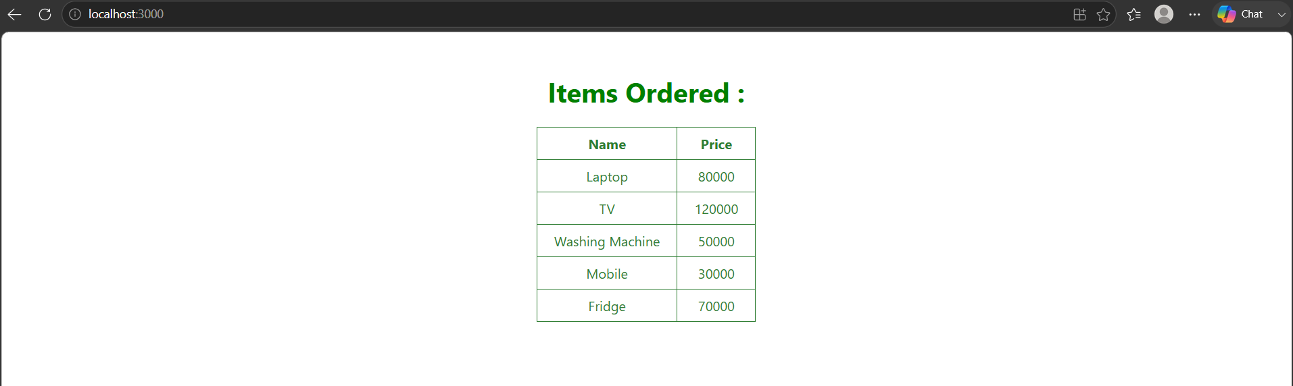
8.ReactJS-HOL:
Solution:
CountPeople.js
import React, { Component } from 'react';

class CountPeople extends Component {
constructor(props) {
super(props);
this.state = {
entrycount: 0,
exitcount: 0,
c: 0
};
}

// Arrow functions automatically bind 'this'
updateEntry = () => {
this.setState((prevState) => {
return { entrycount: prevState.entrycount + 1 };
});
};

updateExit = () => {
this.setState((prevState) => {
return { exitcount: prevState.exitcount + 1 };
});
};

render() {
return (
<div style={{ display: 'flex', justifyContent: 'space-around', marginTop: '20%' }}>
<div>
<button
style={{ backgroundColor: 'lightgreen', padding: '5px 10px', marginRight: '5px' }}
onClick={this.updateEntry}
>
Login
</button>
<span>{this.state.entrycount} People Entered!!!</span>
</div>

<div>
<button
style={{ backgroundColor: 'lightgreen', padding: '5px 10px', marginRight: '5px' }}
onClick={this.updateExit}
>
Exit
</button>
<span>{this.state.exitcount} People Left!!!</span>
</div>
</div>
);
}
}

export default CountPeople;
App.js
import React from 'react';
import './App.css';
import CountPeople from './CountPeople';

function App() {
return (
<div className="App">
<CountPeople />
</div>
);
}

export default App;
result:
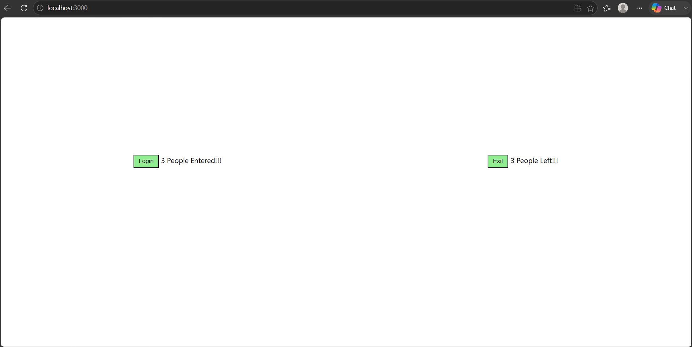
9.ReactJS-HOL
ListofPlayers.js:
import React from 'react';

// Player list matching the output image exact values and names
const players = [
{ name: "Jack", score: 50 },
{ name: "Michael", score: 70 },
{ name: "John", score: 40 },
{ name: "Ann", score: 61 },
{ name: "Elisabeth", score: 61 },
{ name: "Sachin", score: 95 },
{ name: "Dhoni", score: 100 },
{ name: "Virat", score: 84 },
{ name: "Jadeja", score: 64 },
{ name: "Raina", score: 75 },
{ name: "Rohit", score: 80 }
];

export function ListofPlayers() {
return (
<div>
{players.map((item) => (
<div key={item.name}>
<li>
Mr. {item.name} <span>{item.score}</span>
</li>
</div>
))}
</div>
);
}

export function Scorebelow70() {
const players70 = [];

players.map((item) => {
if (item.score <= 70) {
players70.push(item);
}
return null;
});

return (
<div>
{players70.map((item) => (
<div key={item.name}>
<li>
Mr. {item.name} <span>{item.score}</span>
</li>
</div>
))}
</div>
);
}
IndianPlayers.js:
import React from 'react';

// Array for Odd/Even destructuring exercise
export const IndianTeam = ['Sachin1', 'Dhoni2', 'Virat3', 'Rohit4', 'Yuvraj5', 'Raina6'];

// ES6 Array Destructuring for Odd positions (1st, 3rd, 5th)
export function OddPlayers([first, , third, , fifth]) {
return (
<div>
<li>First : {first}</li>
<li>Third : {third}</li>
<li>Fifth : {fifth}</li>
</div>
);
}

// ES6 Array Destructuring for Even positions (2nd, 4th, 6th)
export function EvenPlayers([, second, , fourth, , sixth]) {
return (
<div>
<li>Second : {second}</li>
<li>Fourth : {fourth}</li>
<li>Sixth : {sixth}</li>
</div>
);
}

// ES6 Spread Operator / Array Merging
const T20Players = ['First Player', 'Second Player', 'Third Player'];
const RanjiTrophyPlayers = ['Fourth Player', 'Fifth Player', 'Sixth Player'];

export const IndianPlayers = [...T20Players, ...RanjiTrophyPlayers];

export function ListofIndianPlayers({ IndianPlayers }) {
return (
<div>
{IndianPlayers.map((player) => (
<div key={player}>
<li>Mr. {player}</li>
</div>
))}
</div>
);
}
App.js:
import React from 'react';
import './App.css';
import { ListofPlayers, Scorebelow70 } from './ListofPlayers';
import { OddPlayers, EvenPlayers, IndianTeam, IndianPlayers, ListofIndianPlayers } from './IndianPlayers';

function App() {
var flag = true; // Toggle between true and false to switch views

if (flag === true) {
return (
<div>
<h1>List of Players</h1>
<ListofPlayers />
<hr />
<h1>List of Players having Scores Less than 70</h1>
<Scorebelow70 />
</div>
);
} else {
return (
<div>
<div>
<h1>Odd Players</h1>
{OddPlayers(IndianTeam)}
<hr />
<h1>Even Players</h1>
{EvenPlayers(IndianTeam)}
</div>
<hr />
<div>
<h1>List of Indian Players Merged:</h1>
<ListofIndianPlayers IndianPlayers={IndianPlayers} />
</div>
</div>
);
}
}

export default App;
RESULT:
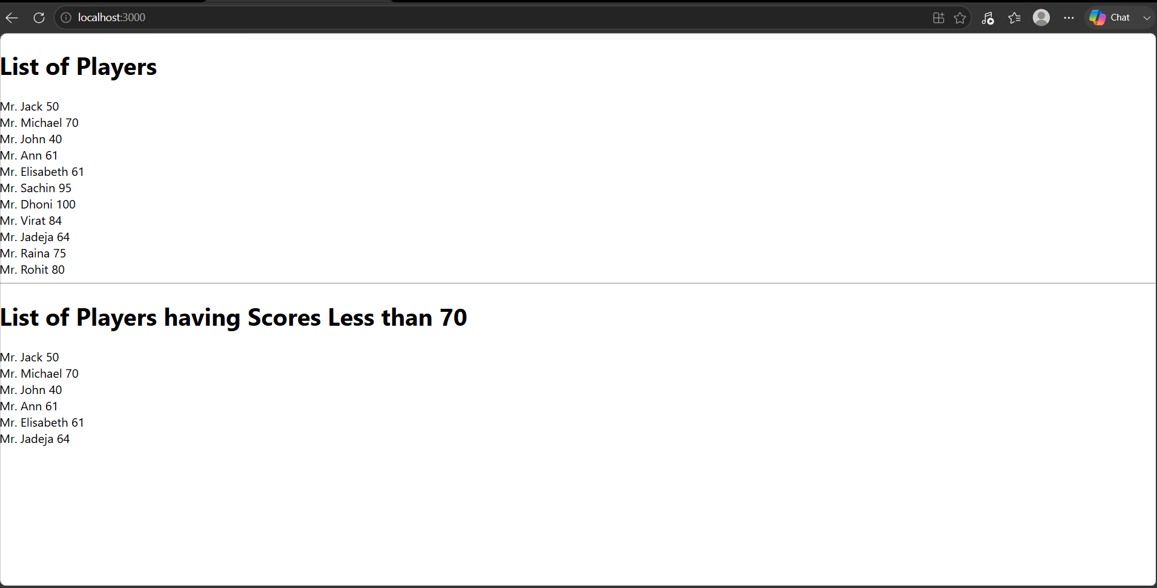
10.ReactJS-HOL
App.css:
.App {
padding: 20px 40px;
font-family: Arial, sans-serif;
}

.textRed {
color: red;
}

.textGreen {
color: green;
}
App.js
import React from 'react';
import './App.css';
import sr from './office.jpg';

function App() {
const element = "Office Space";
const jsxatt = <img src={sr} width="25%" height="25%" alt="Office Space" />;
const ItemName = { Name: "DBS", Rent: 50000, Address: 'Chennai' };
const officeList = [
{ Name: "DBS", Rent: 50000, Address: 'Chennai' },
{ Name: "Regus", Rent: 75000, Address: 'Bangalore' },
{ Name: "WeWork", Rent: 55000, Address: 'Mumbai' }
];
let colors = [];
if (ItemName.Rent <= 60000) {
colors.push('textRed');
} else {
colors.push('textGreen');
}

return (
<div className="App">
<h1>{element} , at Affordable Range </h1>
{jsxatt}
<h1>Name: {ItemName.Name}</h1>
<h3 className={colors[0]}>Rent: Rs. {ItemName.Rent}</h3>
<h3>Address: {ItemName.Address}</h3>

<hr style={{ margin: '40px 0' }} />

<h2>All Office Spaces</h2>
{officeList.map((office, index) => {
let rentColor = office.Rent <= 60000 ? 'textRed' : 'textGreen';
return (
<div key={index} style={{ marginBottom: '20px' }}>
<h2>Name: {office.Name}</h2>
<h3 className={rentColor}>Rent: Rs. {office.Rent}</h3>
<h3>Address: {office.Address}</h3>
</div>
);
})}
</div>
);
}

export default App;
RESULT:
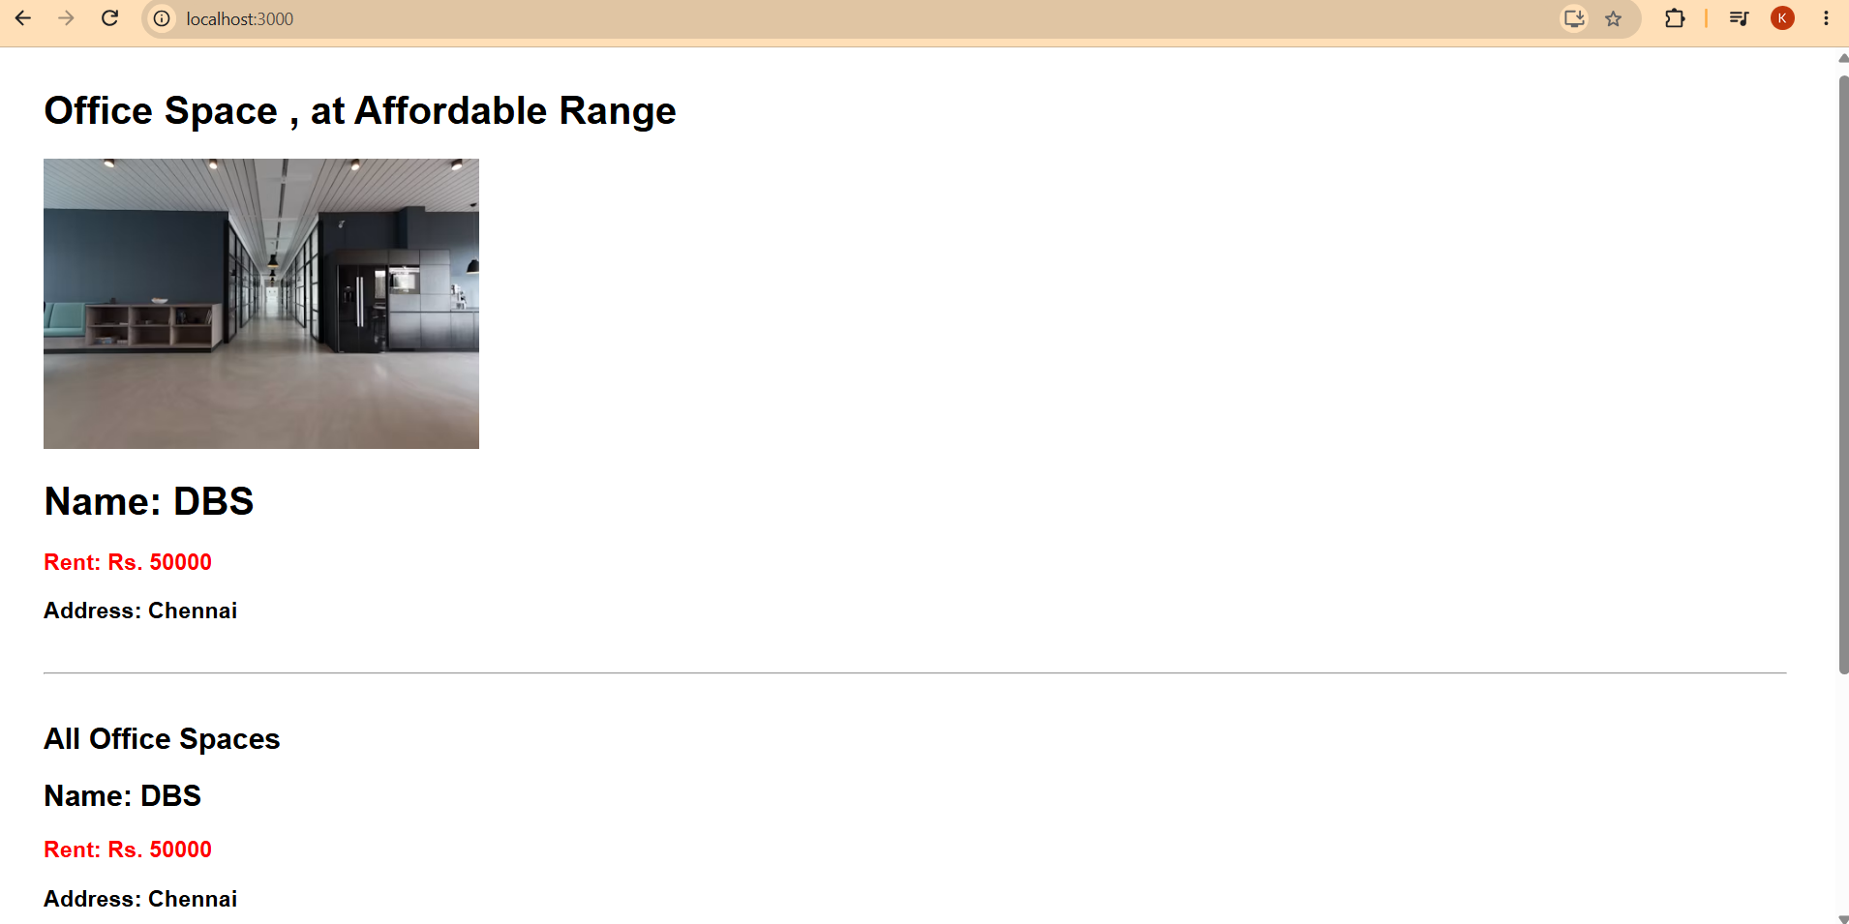
11.ReactJS-HOL
CurrencyConvertor.js:
import React, { Component } from 'react';

class CurrencyConvertor extends Component {
constructor(props) {
super(props);
this.state = {
amount: '',
currency: ''
};
}

handleChange = (event) => {
this.setState({ [event.target.name]: event.target.value });
};

handleSubmit = (event) => {
event.preventDefault();
const { amount, currency } = this.state;
let convertedAmount = Number(amount) * 80;

alert(`Converting to ${currency} Amount is ${convertedAmount}`);
};

render() {
return (
<div style={{ marginTop: '20px' }}>
<h1 style={{ color: 'green' }}>Currency Convertor!!!</h1>
<form onSubmit={this.handleSubmit}>
<div style={{ marginBottom: '10px' }}>
<label style={{ marginRight: '10px' }}>Amount:</label>
<input
type="text"
name="amount"
value={this.state.amount}
onChange={this.handleChange}
/>
</div>
<div style={{ marginBottom: '10px' }}>
<label style={{ marginRight: '10px' }}>Currency:</label>
<textarea
name="currency"
rows="1"
value={this.state.currency}
onChange={this.handleChange}
/>
</div>
<div style={{ marginLeft: '70px' }}>
<button type="submit">Submit</button>
</div>
</form>
</div>
);
}
}

export default CurrencyConvertor;
App.js:
import React, { Component } from 'react';
import './App.css';
import CurrencyConvertor from './CurrencyConvertor';

class App extends Component {
constructor(props) {
super(props);
this.state = {
counter: 0
};
}
incrementCounter = () => {
this.setState((prevState) => ({
counter: prevState.counter + 1
}));
};
sayHello = () => {
alert('Hello! Member1');
};

handleIncrement = () => {
this.incrementCounter();
this.sayHello();
};
handleDecrement = () => {
this.setState((prevState) => ({
counter: prevState.counter - 1
}));
};
sayWelcome = (message) => {
alert(message);
};
handleClick = (e) => {
alert('I was clicked');
};

render() {
return (
<div style={{ padding: '20px' }}>
<h2>{this.state.counter}</h2>

<div style={{ display: 'flex', flexDirection: 'column', width: '100px', gap: '5px' }}>
<button onClick={this.handleIncrement}>Increment</button>
<button onClick={this.handleDecrement}>Decrement</button>
<button onClick={() => this.sayWelcome('welcome')}>Say welcome</button>
<button onClick={this.handleClick}>Click on me</button>
</div>

<CurrencyConvertor />
</div>
);
}
}
export default App;
RESULT:
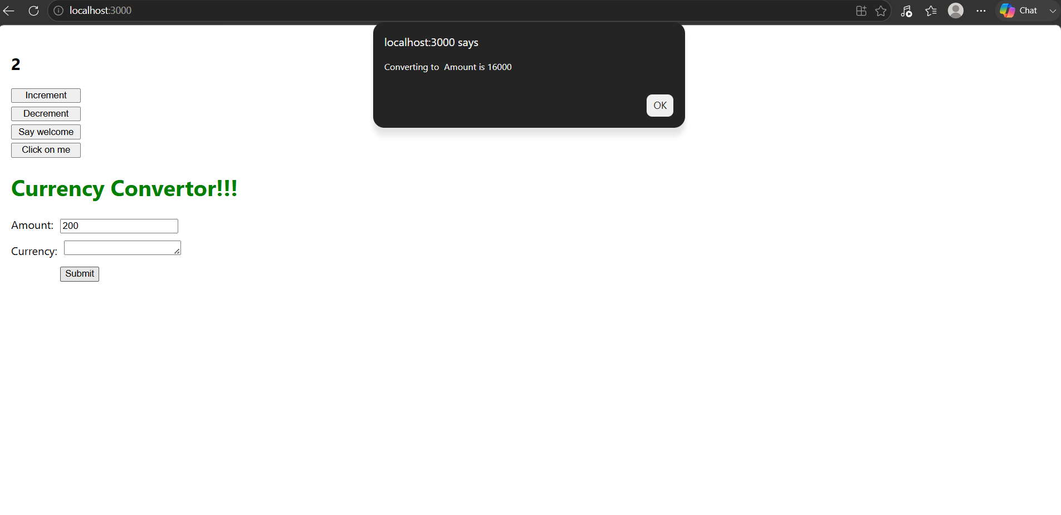
12.ReactJS-HOL:
App.js:
import React, { Component } from 'react';
import './App.css';
function UserGreeting() {
return <h1>Welcome back</h1>;
}
function GuestGreeting() {
return <h1>Please sign up.</h1>;
}
function Greeting(props) {
const isLoggedIn = props.isLoggedIn;
if (isLoggedIn) {
return <UserGreeting />;
}
return <GuestGreeting />;
}
function LoginButton(props) {
return (
<button onClick={props.onClick}>
Login
</button>
);
}
function LogoutButton(props) {
return (
<button onClick={props.onClick}>
Logout
</button>
);
}
class App extends Component {
constructor(props) {
super(props);
this.state = { isLoggedIn: false };
}

handleLoginClick = () => {
this.setState({ isLoggedIn: true });
};

handleLogoutClick = () => {
this.setState({ isLoggedIn: false });
};

render() {
const isLoggedIn = this.state.isLoggedIn;

let button;
if (isLoggedIn) {
button = <LogoutButton onClick={this.handleLogoutClick} />;
} else {
button = <LoginButton onClick={this.handleLoginClick} />;
}

return (
<div style={{ padding: '50px 100px' }}>
<Greeting isLoggedIn={isLoggedIn} />
{button}
</div>
);
}
}

export default App;
RESULT:
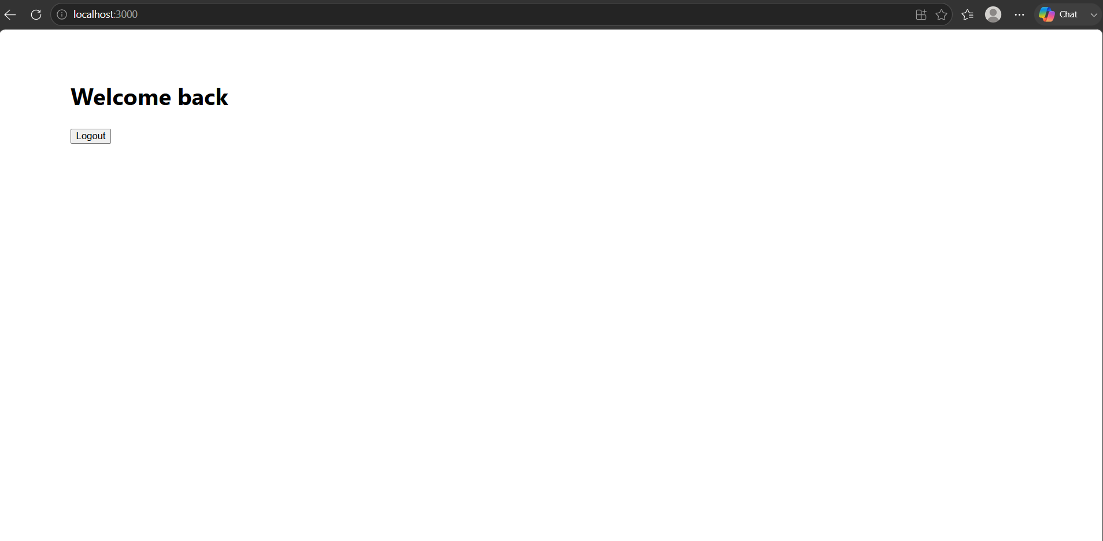
13.ReactJS-HOL:
App.js:
import React from 'react';
import './App.css';

// 1. Data arrays matching hint structure
export const books = [
{ id: 101, bname: 'Master React', price: 670 },
{ id: 102, bname: 'Deep Dive into Angular 11 ', price: 800 },
{ id: 103, bname: 'Mongo Essentials', price: 450 },
];

export const courses = [
{ id: 201, cname: 'Angular', date: '4/5/2021' },
{ id: 202, cname: 'React', date: '6/3/20201' },
];

export const blogs = [
{
id: 301,
title: 'React Learning',
author: 'Stephen Biz',
desc: 'Welcome to learning React!'
},
{
id: 302,
title: 'Installation',
author: 'Schewzdenier',
desc: 'You can install React from npm.'
}
];

function App() {
// 2. Element Variables built using map() and unique keys matching lab hints
const coursedet = (
<ul>
{courses.map((course) => (
<div key={course.id} style={{ marginBottom: '25px' }}>
<h2>{course.cname}</h2>
<p><strong>{course.date}</strong></p>
</div>
))}
</ul>
);

const bookdet = (
<ul>
{books.map((book) => (
<div key={book.id} style={{ marginBottom: '25px' }}>
<h3>{book.bname}</h3>
<h4>{book.price}</h4>
</div>
))}
</ul>
);

const content = (
<div>
{blogs.map((blog) => (
<div key={blog.id} style={{ marginBottom: '25px' }}>
<h2>{blog.title}</h2>
<p><strong>{blog.author}</strong></p>
<p>{blog.desc}</p>
</div>
))}
</div>
);

// 3. Render 3 columns matching screenshot layout structure
return (
<div className="container">
{/* Course Details Column */}
<div className="column mystyle1">
<h1>Course Details</h1>
{coursedet}
</div>

{/* Book Details Column */}
<div className="column st2">
<h1>Book Details</h1>
{bookdet}
</div>

{/* Blog Details Column */}
<div className="column v1">
<h1>Blog Details</h1>
{content}
</div>
</div>
);
}

export default App;
App.css:
.container {
display: flex;
justify-content: space-around;
padding: 40px;
font-family: Arial, sans-serif;
}

.column {
flex: 1;
padding: 0 20px;
text-align: center;
}

/* Green vertical border separator */
.column:not(:last-child) {
border-right: 4px solid green;
}

ul {
list-style-type: none;
padding: 0;
}

h1 {
font-size: 2rem;
margin-bottom: 20px;
}

h2 {
font-size: 1.5rem;
margin-top: 20px;
}
RESULT:
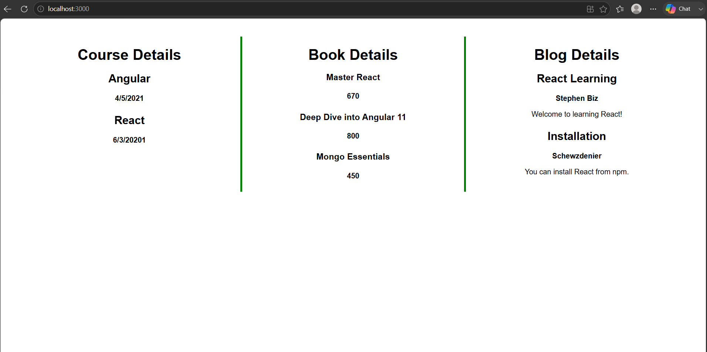
14.ReactJS-HOL:
ThemeContext.js:
import { createContext } from 'react';
const ThemeContext = createContext('light');

export default ThemeContext;
App.js
import React, { useState } from 'react';
import ThemeContext from './ThemeContext';
import EmployeeList from './EmployeeList';

function App() {
const [theme, setTheme] = useState('light'); // or state setup matching your existing code

return (
// Wrap entire JSX in ThemeContext.Provider
<ThemeContext.Provider value={theme}>
<div className="App">
{/* Remove theme prop from EmployeeList */}
<EmployeeList />
</div>
</ThemeContext.Provider>
);
}

export default App;
EmployeeList.js
import React from 'react';
import EmployeeCard from './EmployeeCard';

function EmployeeList(props) {
// Assuming employees list or other props are passed
return (
<div className="employee-list">
{/* Do NOT pass theme prop anymore */}
<EmployeeCard />
</div>
);
}

export default EmployeeList;
EmployeeCard.js:
import React, { useContext } from 'react';
import ThemeContext from './ThemeContext';

function EmployeeCard(props) {
// Consume theme context value
const theme = useContext(ThemeContext);

return (
<div className="employee-card">
<h3>Employee Details</h3>
{/* Use the context variable for the button's className */}
<button className={`btn btn-${theme}`}>
Action Button
</button>
</div>
);
}

export default EmployeeCard;
RESULT:
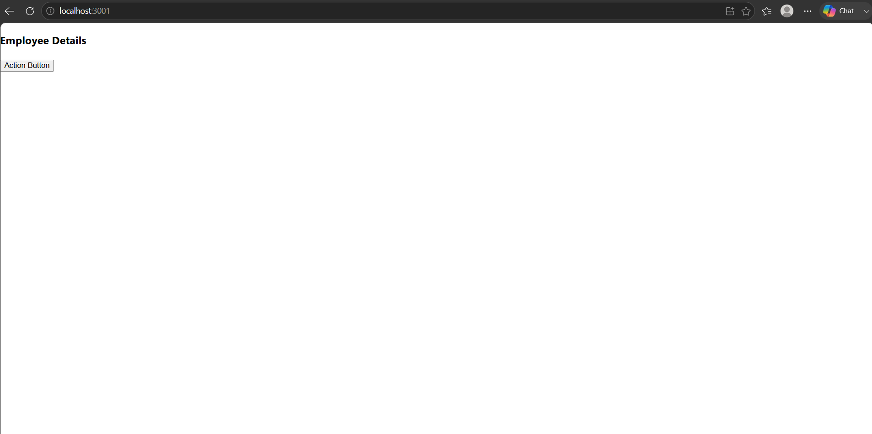
15.ReactJS-HOL:
ComplaintRegister.js:
import React, { Component } from 'react';

class ComplaintRegister extends Component {
constructor(props) {
super(props);
this.state = {
ename: '',
complaint: '',
NumberHolder: Math.floor(Math.random() * 100) + 1 // Generates a reference number
};

this.handleChange = this.handleChange.bind(this);
this.handleSubmit = this.handleSubmit.bind(this);
}

// Generic change handler using computed property names
handleChange(event) {
this.setState({ [event.target.name]: event.target.value });
}

// Submit handler to trigger alert and prevent default form refresh
handleSubmit(event) {
var msg = 'Thanks ' + this.state.ename + '.\nYour Complaint was Submitted.\nTransaction ID is: ' + this.state.NumberHolder;
alert(msg);
event.preventDefault();
}

render() {
return (
<div style={{ textAlign: 'center', marginTop: '50px' }}>
<h1 style={{ color: 'red' }}>Register your complaints here!!!</h1>

<form onSubmit={this.handleSubmit}>
<div style={{ margin: '15px 0' }}>
<label htmlFor="ename" style={{ fontWeight: 'bold', marginRight: '20px' }}>
Name:
</label>
<input
type="text"
id="ename"
name="ename"
value={this.state.ename}
onChange={this.handleChange}
style={{ width: '200px', padding: '4px' }}
required
/>
</div>

<div style={{ margin: '15px 0' }}>
<label htmlFor="complaint" style={{ fontWeight: 'bold', marginRight: '10px' }}>
Complaint:
</label>
<textarea
id="complaint"
name="complaint"
value={this.state.complaint}
onChange={this.handleChange}
rows="3"
style={{ width: '200px', padding: '4px', verticalAlign: 'top' }}
required
/>
</div>

<div style={{ marginTop: '15px' }}>
<button type="submit" style={{ padding: '4px 12px', cursor: 'pointer' }}>
Submit
</button>
</div>
</form>
</div>
);
}
}

export default ComplaintRegister;
App.js:
import React from 'react';
import ComplaintRegister from './ComplaintRegister';

function App() {
return (
<div className="App">
<ComplaintRegister />
</div>
);
}

export default App;
RESULT:
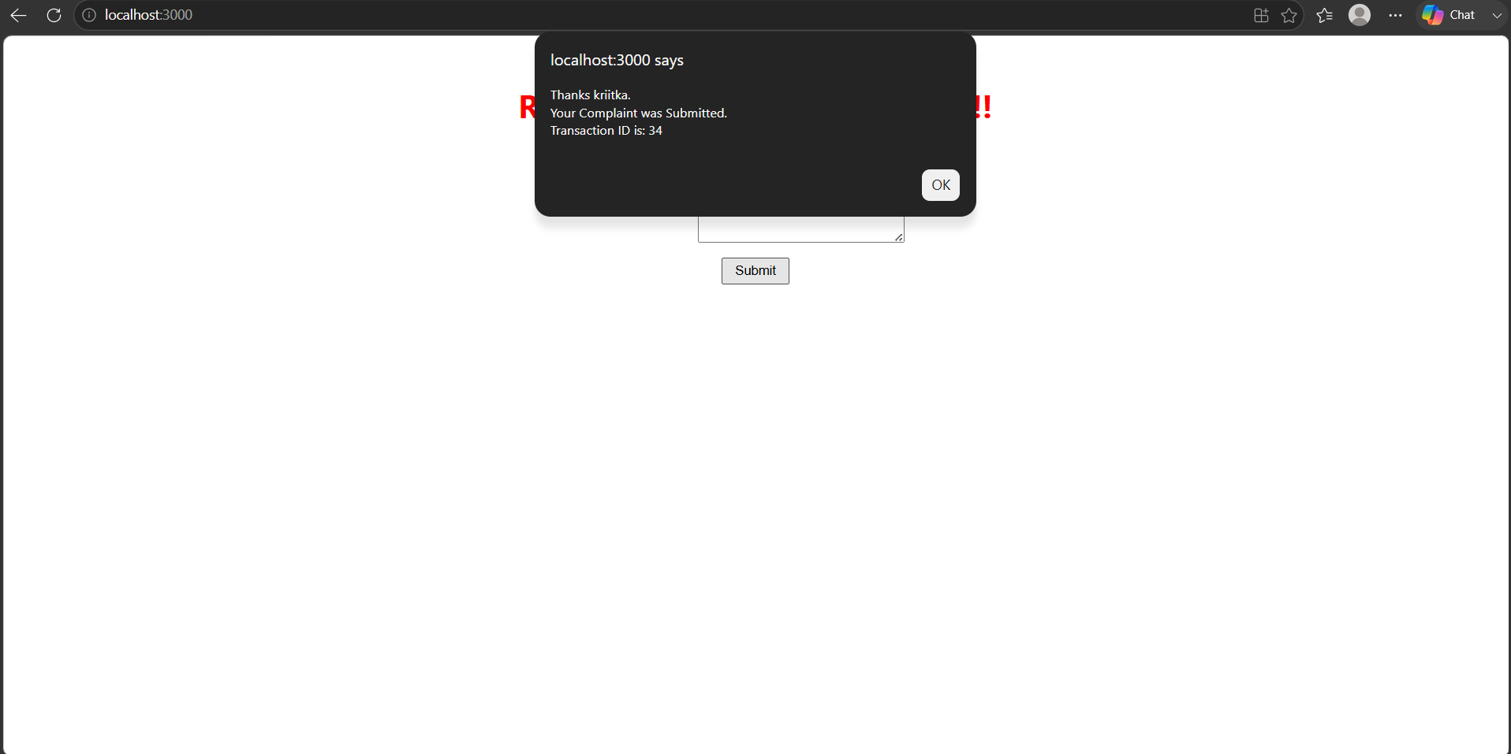
16.ReactJS-HOL:
Register.js:
import React, { Component } from 'react';
const validEmailRegex = RegExp(
/^(([^<>()[\]\\.,;:\s@"]+(\.[^<>()[\]\\.,;:\s@"]+)*)|(".+"))@((\[[0-9]{1,3}\.[0-9]{1,3}\.[0-9]{1,3}\.[0-9]{1,3}\])|(([a-zA-Z\-0-9]+\.)+[a-zA-Z]{2,}))$/i
);
const validateForm = (errors) => {
let valid = true;
Object.values(errors).forEach((val) => {
if (val.length > 0) {
valid = false;
}
});
return valid;
};

class Register extends Component {
constructor(props) {
super(props);
this.state = {
fullName: '',
email: '',
password: '',
errors: {
fullName: 'Full Name must be 5 characters long!',
email: 'Email is not valid!',
password: 'Password must be 8 characters long!'
}
};
}

// Handle input changes and perform realtime validation per field
handleChange = (event) => {
event.preventDefault();
const { name, value } = event.target;
let errors = this.state.errors;

switch (name) {
case 'fullName':
errors.fullName =
value.length < 5
? 'Full Name must be 5 characters long!'
: '';
break;
case 'email':
errors.email =
validEmailRegex.test(value)
? ''
: 'Email is not valid!';
break;
case 'password':
errors.password =
value.length < 8
? 'Password must be 8 characters long!'
: '';
break;
default:
break;
}

this.setState({ errors, [name]: value });
};

// Submit handler evaluating errors and triggering alert popups
handleSubmit = (event) => {
event.preventDefault();

if (validateForm(this.state.errors)) {
alert('Valid Form');
} else {
if (this.state.errors.fullName !== '') {
alert(this.state.errors.fullName);
}
if (this.state.errors.email !== '') {
alert(this.state.errors.email);
}
if (this.state.errors.password !== '') {
alert(this.state.errors.password);
}
}
};

render() {
return (
<div style={{ textAlign: 'center', marginTop: '50px' }}>
<h1 style={{ color: 'red' }}>Register Here!!!</h1>

<form onSubmit={this.handleSubmit}>
<div style={{ margin: '15px 0' }}>
<label htmlFor="fullName" style={{ fontWeight: 'bold', marginRight: '10px' }}>
Name:
</label>
<input
type="text"
id="fullName"
name="fullName"
value={this.state.fullName}
onChange={this.handleChange}
style={{ width: '200px', padding: '4px' }}
/>
</div>

<div style={{ margin: '15px 0' }}>
<label htmlFor="email" style={{ fontWeight: 'bold', marginRight: '15px' }}>
Email:
</label>
<input
type="text"
id="email"
name="email"
value={this.state.email}
onChange={this.handleChange}
style={{ width: '200px', padding: '4px' }}
/>
</div>

<div style={{ margin: '15px 0' }}>
<label htmlFor="password" style={{ fontWeight: 'bold', marginRight: '5px' }}>
Password:
</label>
<input
type="password"
id="password"
name="password"
value={this.state.password}
onChange={this.handleChange}
style={{ width: '200px', padding: '4px' }}
/>
</div>

<div style={{ marginTop: '15px' }}>
<button type="submit" style={{ padding: '4px 12px', cursor: 'pointer' }}>
Submit
</button>
</div>
</form>
</div>
);
}
}

export default Register;
App.js
import React from 'react';
import Getuser from './Getuser';

function App() {
return (
<div className="App">
<Getuser />
</div>
);
}

export default App;
RESULT:
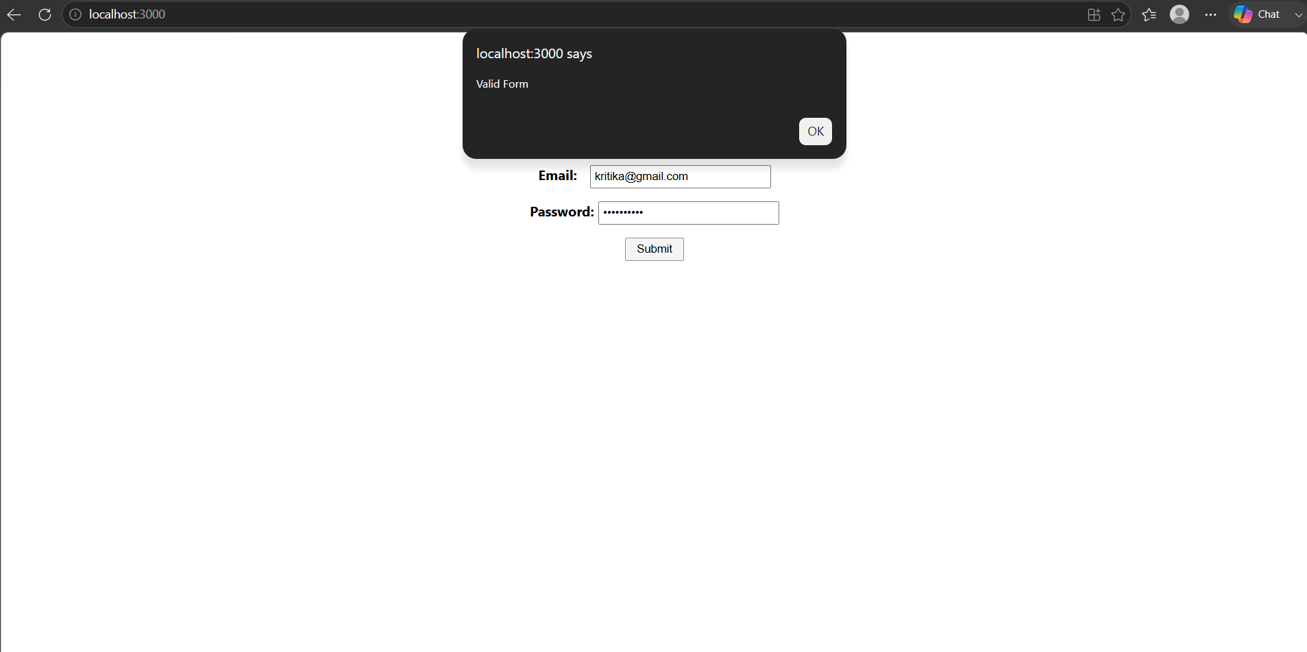
17.ReactJS-HOL:
Getuser.js:
import React, { Component } from 'react';

class Getuser extends Component {
constructor(props) {
super(props);
this.state = {
loading: true,
person: null
};
}
async componentDidMount() {
const url = "https://api.randomuser.me/";
const response = await fetch(url);
const data = await response.json();
this.setState({ person: data.results[0], loading: false });
console.log(data.results[0]);
}

render() {
if (this.state.loading) {
return <div>loading...</div>;
}
if (!this.state.person) {
return <div>didn't get a person</div>;
}

const { name, picture } = this.state.person;

return (
<div style={{ paddingLeft: '150px', paddingTop: '100px' }}>
<h1 style={{ margin: '0 0 15px 0' }}>
{name.title} {name.first} {name.last}
</h1>
<img
src={picture.large}
alt="User Profile"
style={{ width: '128px', height: '128px', borderRadius: '4px' }}
/>
</div>
);
}
}

export default Getuser;
App.js:
import React from 'react';
import Getuser from './Getuser';

function App() {
return (
<div className="App">
<Getuser />
</div>
);
}

export default App;
RESULT:
